Process and Evaluation Documentation

## Evaluation plan:

For the think-aloud study the following tasks were designed to make the user want to interact will all elements of our visualization:

* Analyze whether there is a significant disparity between the popular vote and the jury vote for Spain in the 2019 Eurovision Song Contest
* Analyze whether the change in 2011 to 2012 to no longer allow voting during the performances changes the way the public votes
* Analyze which composers have been the most successful last year
* Assess how Conchita Wurst's performance in Eurovision 2014 resonated with the Polish audience, considering societal attitudes towards LGBTQ+ minorities.
* Assess the effect the war on Ukraine had on Eurovision voting trends
* Analyze whether composers that appeared more often in Eurovision are more successful than those that appear once or twice

For this study a PowerPoint was used. The participant would say they would look at the map, and then we would show the participant a sketch that would represent what they would then see. The PowerPoint in its entirety can be seen in appendix A.

## Observations

After the think-aloud study the notes that had been taken (found in appendix B) and were translated into the following improvement points:

#### **Usability**

* **Map Usage:** Users struggle with selecting the desire countries
* **Scatterplot Understanding:** User felt confused about the information being displayed. They suggested adding labels
* **Time Period Selection:** Users struggle between viewing data for a single year vs. multiple years, the granularity was not clear.

#### **Interaction**

* **Filtering multiple years at once:** Various of the participants showed a desire to be able to aggregate the results of multiple years at once
* **Interact through clicking in the map:** Participants expected a clear interaction between the map and the piramid when clicking over a country in the map.

#### **Visualization**

* **Pyramid Graph:**People where quite not sure with the usage and thought that required user selection.

#### **General Observations**

* **Scatter Plot Disconect**: Users often connect the map and pyramid, but not the scatterplot.
* **Jury vote vs. popular:** Vote distinction took time to understand, that could be given lack of expertise on our domain..

## Lessons learned

Based on the feedback given it was important that the connection between the visualizations was made clearer. If a user interacts with one part, for example selecting a country on the map visualization, then other parts should also react, like highlighting composers who worked for those countries in the scatter plot visualization.

We also decided to make it possible to select a range of years instead of just one year.

There was also general confusion on what exactly the different visualizations did, so it is important to give them correct and clear names. In addition, for the pyramid visualization there was some confusion on what the middle axis meant, therefore we have decided to make the label of the middle axis more clear, in addition, if a country is selected that specific country will also light up in the pyramid visualization, thereby making that connection stronger and more clear.

It became clear that the scatter plot visualization was less connected to the other two visualizations, and that it might be better to change it. However, we decided to keep working on this visualization instead of changing it, as that was more feasible for us to do in the time we had left.

## 

# Appendix A: PowerPoint

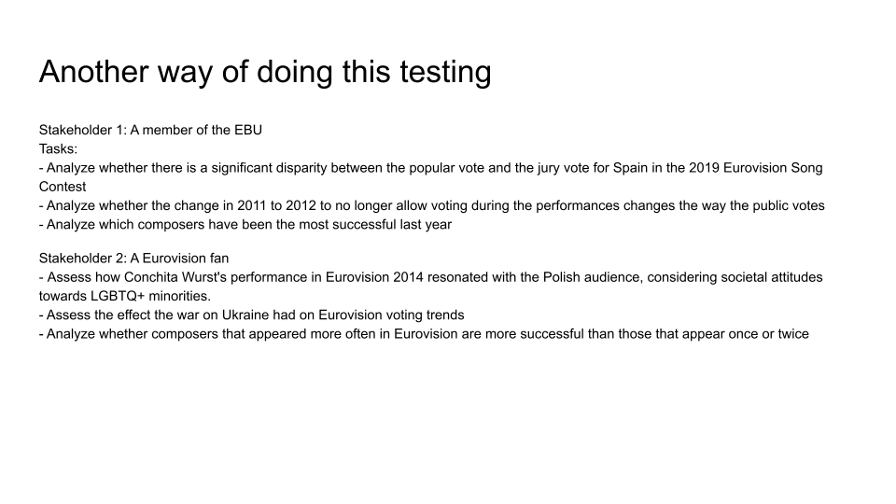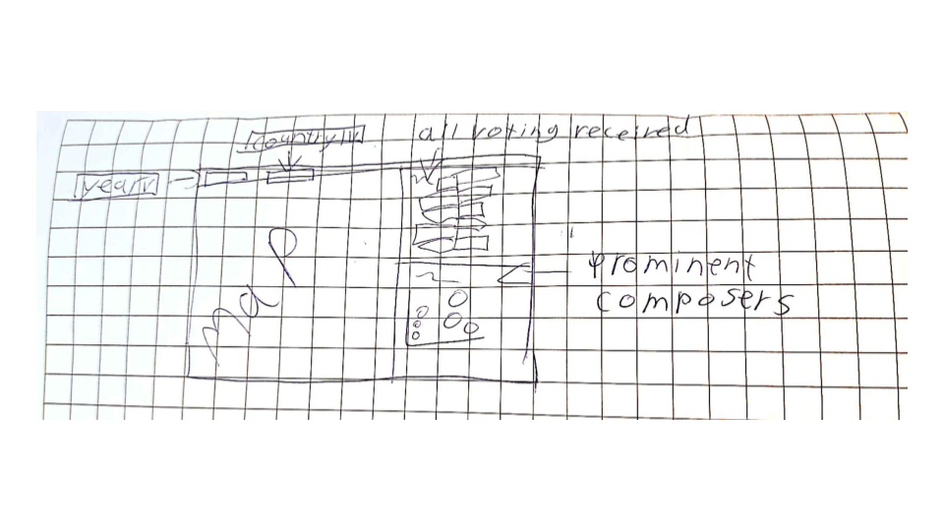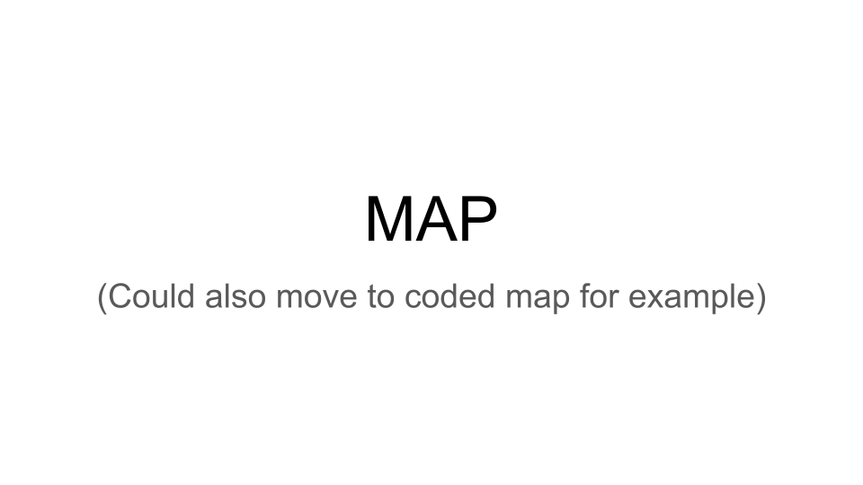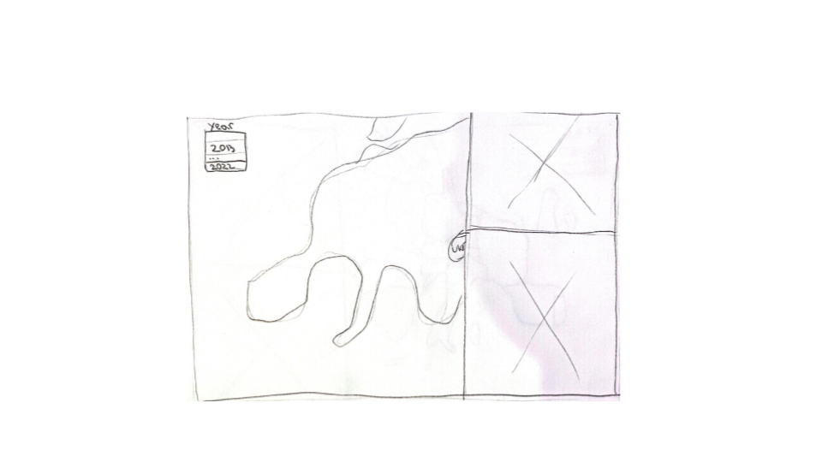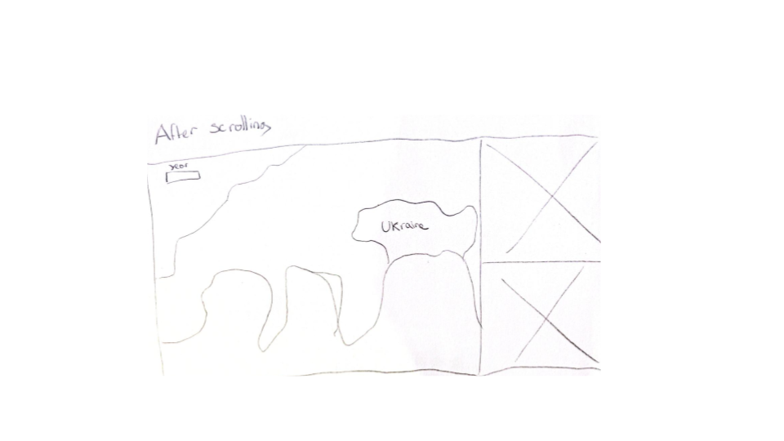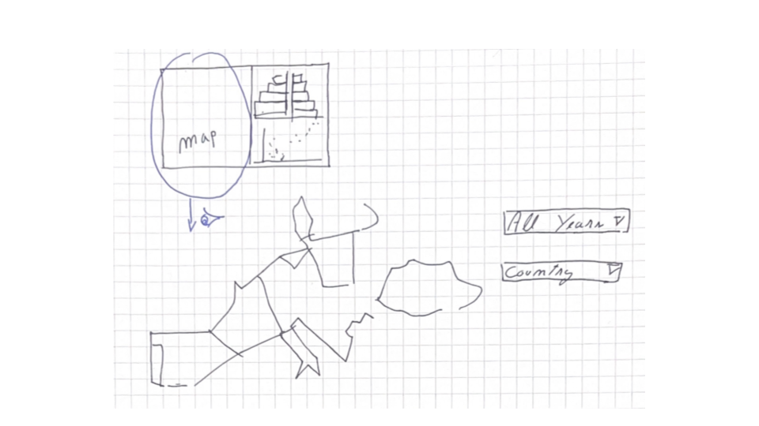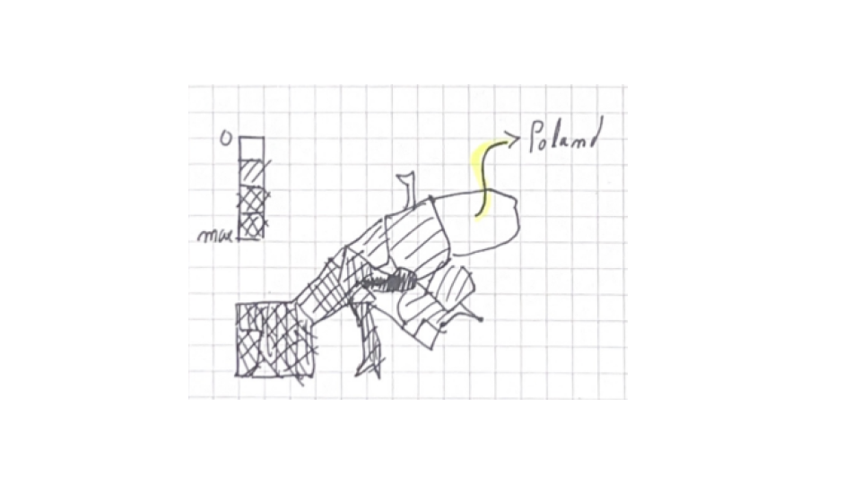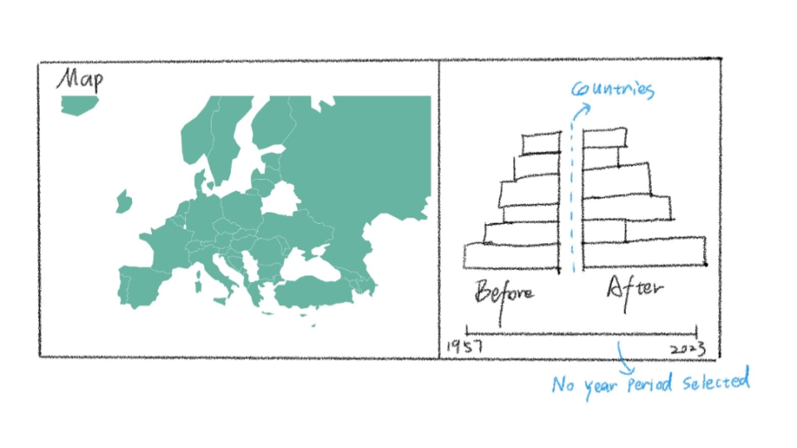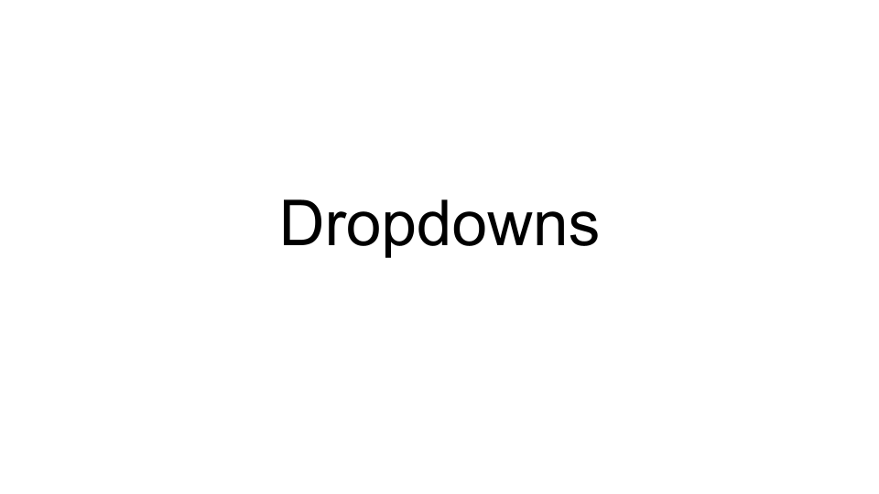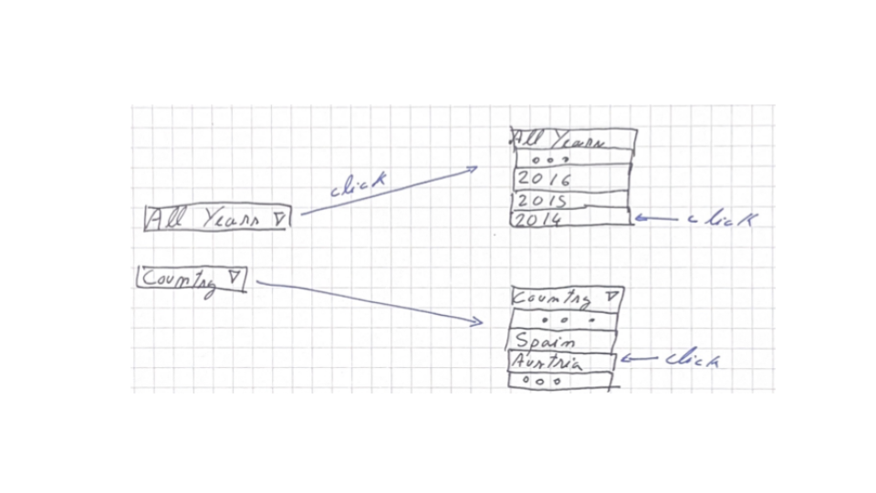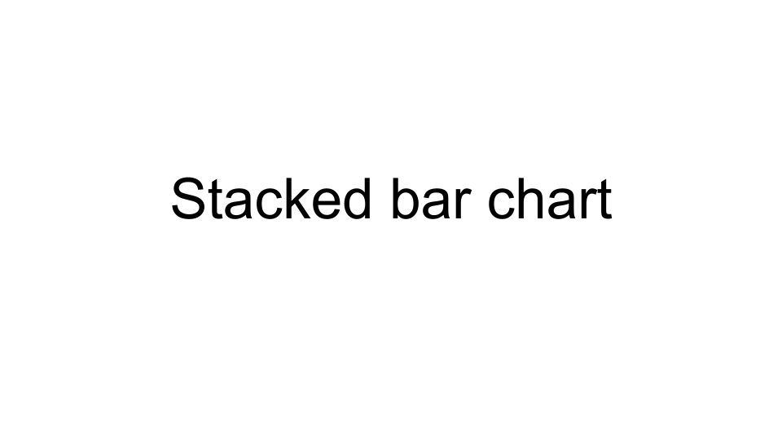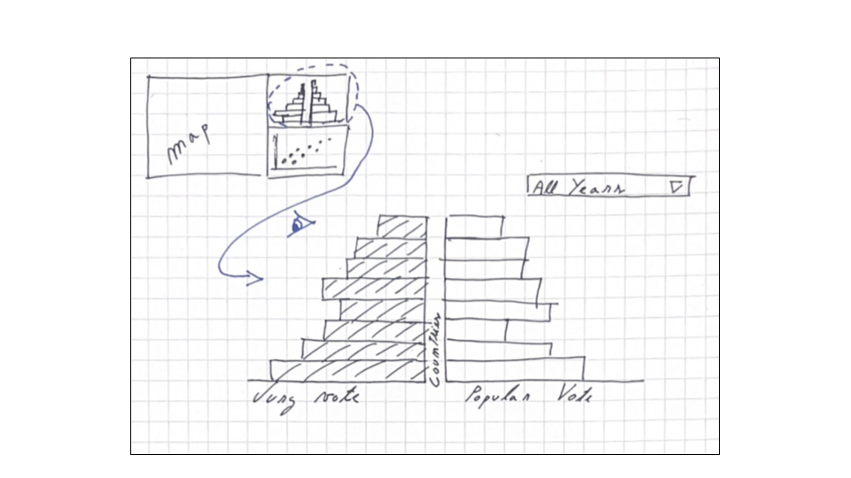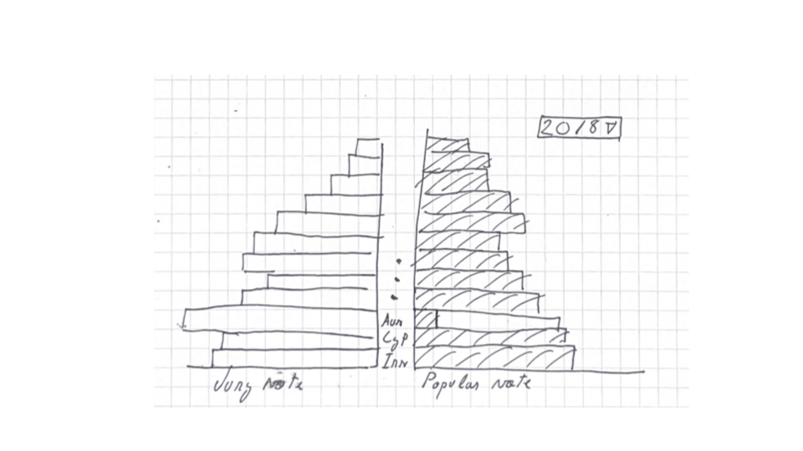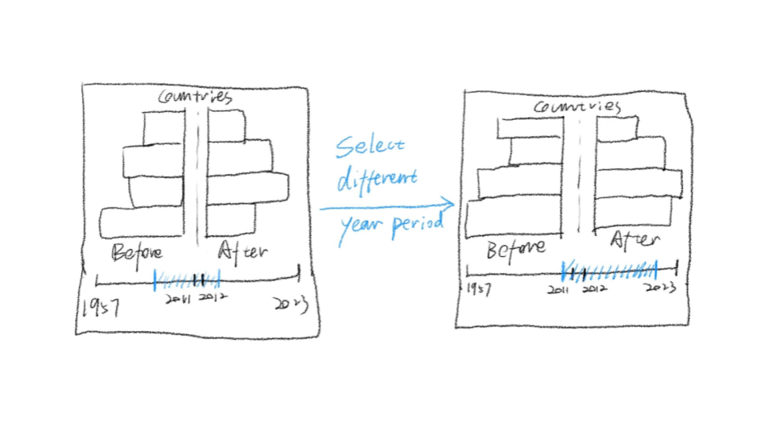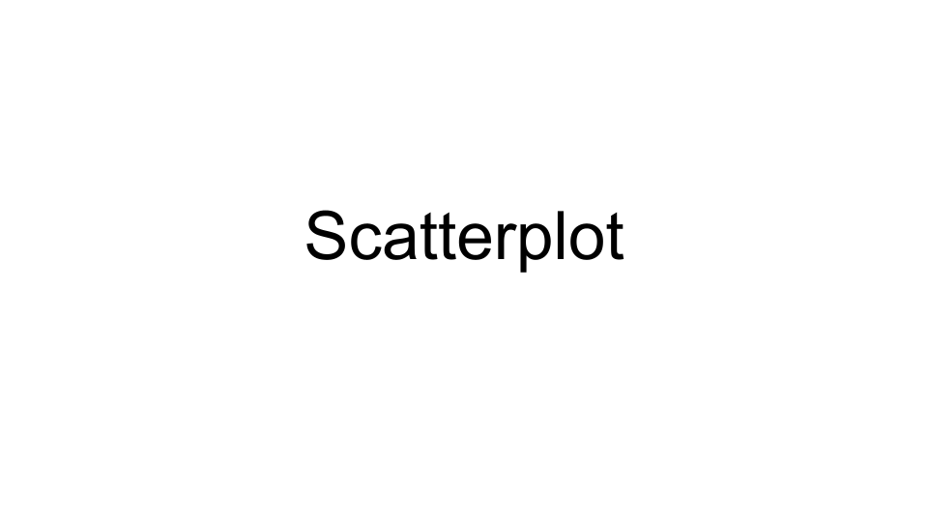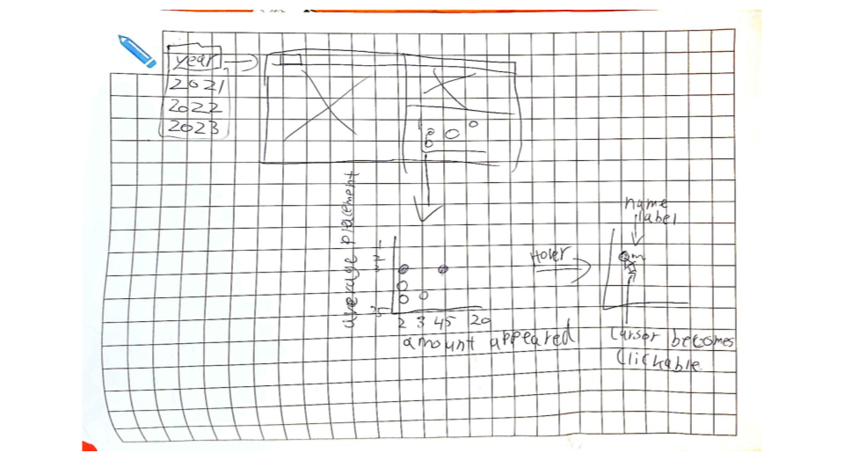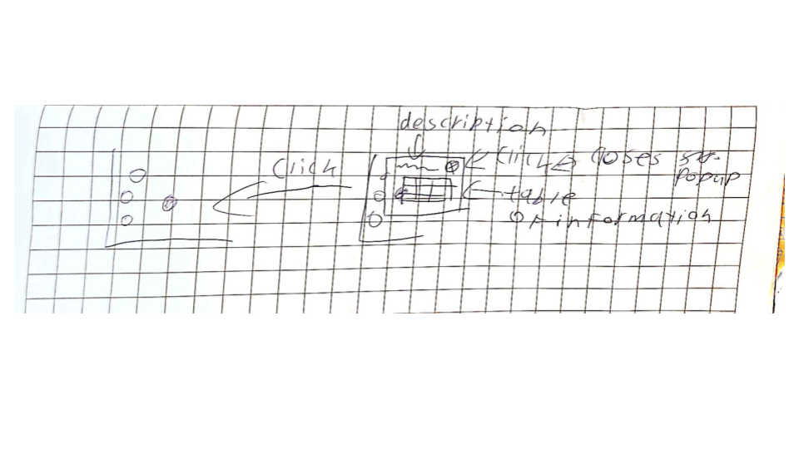

# Appendix B: Notes

During the think-aloud study one member of our group would lead the discussion, the other member would write down notes. Multiple people participated in this study, following are our notes made during the study.

* The composer's part is clear. Multiple filters involved will be better. The bar chart is easy to recognize when the time period changed and the countries’ voting changed. How much one country supports other countries is a good idea but it is not so clear now.
* Would use the map if clickable, if not use the dropdowns. When clicking on a country expects to then see more information (in relation to the Spain votes). Expects highlighting of a country. Confused by the height of the bars. A bit too messy based, expected/wanted some grouping of countries. Struggled between time frame vs 1 year. Misunderstands what the barchart means. Confusion about scatterplot → How many do you want to show? Wants to know which one he can pick and what the difference between them is. Could be overloaded information/doesn’t understand the use. Expects a filter or within a year. What was the overal score?
* Bar chart is interesting but quite similar, the countries in the bar chart are not so clear. Color represents the popular. It’s clear to see the composers and click the dots to see the details. The time period selected is a little confusing.
* Can see the countries in the bar chart and can read it. Missed the jury vote/popular vote at first. But understands if perfectly otherwise. Can understand the map after thinking for a bit. The task (Conchita wurst) makes them look for a way to divide groups, but could not find it. Selects only 1 year at a time, and knows that the pyramid might be nice to see the divide between the public and the jury. Thinks they need to click on a country, and does not connect it with the pyramid. Misunderstands the pyramid → Thinks that you need to have a country selected. Select a time period.
* Confused which graph to use to find the right graphs. being able to overlap the bars.Selection in the map not clear, selected the country they wanted to see
* The countries in the bar chart are not so clear. The heating map about countries voting for selected countries can be added as a title to make it clear. Time period selected in the bar chart about the range of 2011-2012 should be shorter.

General thoughts:

People want to combine/select multiple years or countries

People get confused on how to relate the map with the pyramid ( different granularities)

There is a bit of disconnect between the scatterplot and the map/pyramid. People often connect the map and the pyramid but do not connect it with the scatterplot